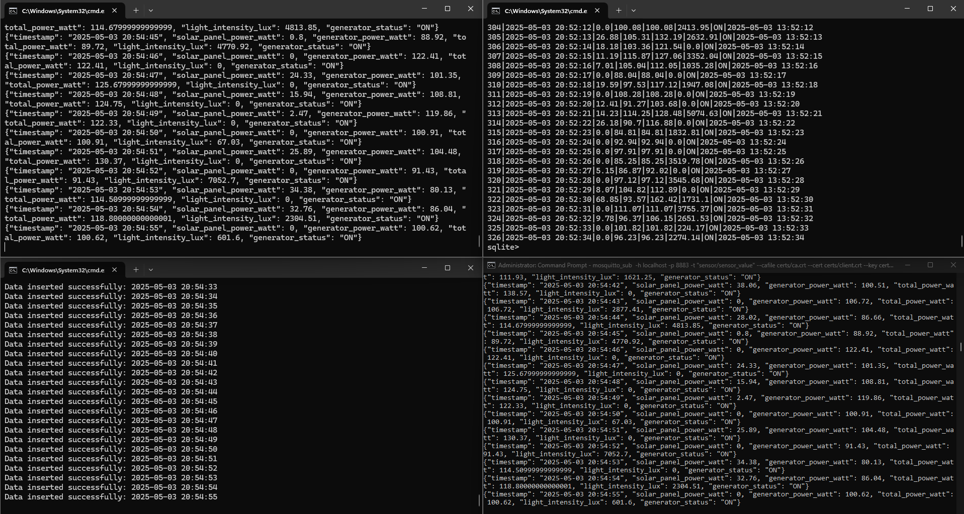

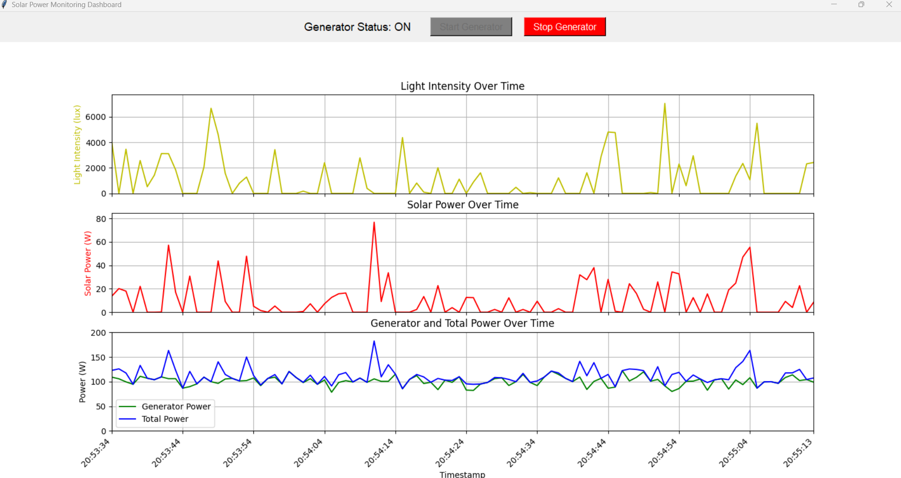

power_intensity_datagen.py
import numpy as np
import time
import datetime
import json
import paho.mqtt.client as mqtt
from paho.mqtt.enums import CallbackAPIVersion
import os
import sys

# Status variable for generator
generator_on = False

# Callback when the client connects to the broker
def on_connect(client, userdata, flags, reason_code, properties=None):
print(f"Connected with result code {reason_code}")
# Subscribe to sensor data topic
client.subscribe("sensor/sensor_value")
# Subscribe to control topic for generator
client.subscribe("control/generator")

# Callback when a message is received from the broker
def on_message(client, userdata, msg):
global generator_on
if msg.topic == "control/generator":
command = msg.payload.decode()
if command == "ON":
generator_on = True
print("Generator turned ON")
elif command == "OFF":
generator_on = False
print("Generator turned OFF")

# Callback when a message is published
def on_publish(client, userdata, mid, reason_code=0, properties=None):
pass

# Function to simulate solar panel power and light intensity based on current time
def calculate_solar_and_light(current_time):
hour = current_time.hour
minute = current_time.minute

# Calculate time-based factor (peak at noon)
time_factor = np.cos((hour - 12 + minute / 60) * np.pi / 12) ** 2

# Set power and light to zero during nighttime (6 PM to 6 AM)
if hour < 6 or hour >= 18:
time_factor = 0

# Base values for solar power and light intensity
base_solar_power = 800 * time_factor # max 800W
base_light_intensity = 100000 * time_factor # max 100,000 lux

# Add random fluctuation
solar_power = base_solar_power + np.random.normal(0, 30)
light_intensity = base_light_intensity + np.random.normal(0, 3000)

# Ensure no negative values
solar_power = max(0, solar_power)
light_intensity = max(0, light_intensity)

return round(solar_power, 2), round(light_intensity, 2)

# Function to simulate generator power output
def calculate_generator_power():
if generator_on:
return round(100 + np.random.normal(0, 10), 2) # approx. 1200W ± 50W
else:
return 0.0

if __name__ == '__main__':
# Define the path to certificate files
parent_dir = r"D:\OneDrive - Digital Government Development Agency (Public Organization)\For me\DADS\IoT\Code\week14"

ca_file = os.path.join(parent_dir, "ca.crt")
cert_file = os.path.join(parent_dir, "client.crt")
key_file = os.path.join(parent_dir, "client.key")

# Create MQTT client
client = mqtt.Client(callback_api_version=CallbackAPIVersion.VERSION2)
client.on_connect = on_connect
client.on_message = on_message
client.on_publish = on_publish

# Set username and password for broker
client.username_pw_set('pk', 'iot1234')

# Set TLS for secure connection
client.tls_set(
ca_certs=ca_file,
certfile=cert_file,
keyfile=key_file
)

# Connect to MQTT broker
client.connect("localhost", 8883, 60)
client.loop_start()

# Infinite loop to send data every second
while True:
now = datetime.datetime.now()
date_time_str = now.strftime("%Y-%m-%d %H:%M:%S")

# Calculate solar power and light intensity
solar_power, light_intensity = calculate_solar_and_light(now)

# Calculate generator power
generator_power = calculate_generator_power()

# Calculate total power
total_power = solar_power + generator_power

# Create data payload
data = {
'timestamp': date_time_str,
'solar_panel_power_watt': solar_power,
'generator_power_watt': generator_power,
'total_power_watt': total_power,
'light_intensity_lux': light_intensity,
'generator_status': "ON" if generator_on else "OFF"
}

# Convert dictionary to JSON string
data_json_str = json.dumps(data)

# Print to console
print(data_json_str)

# Publish data to MQTT topic
client.publish("sensor/sensor_value", data_json_str)

# Wait for 1 second before sending the next message
time.sleep(1)

power_intensity_plotter.py
import paho.mqtt.client as mqtt
from paho.mqtt.enums import CallbackAPIVersion
import json
import matplotlib.pyplot as plt
from collections import deque
import threading
import os
import tkinter as tk
from matplotlib.backends.backend_tkagg import FigureCanvasTkAgg
import time

# =======================
# Configuration Section
# =======================

# Maximum number of data points to display
max_len = 100

# Deques for storing time-series data
timestamps = deque(maxlen=max_len)
solar_powers = deque(maxlen=max_len)
generator_powers = deque(maxlen=max_len)
total_powers = deque(maxlen=max_len)
light_intensities = deque(maxlen=max_len)

# Global variables
generator_status = "OFF"
client = None

# =======================
# MQTT Callback Functions
# =======================

def on_connect(client, userdata, flags, reason_code, properties=None):
"""Called when the client connects to the MQTT broker."""
print(f"Connected with result code {reason_code}")
client.subscribe("sensor/sensor_value")

def on_message(client, userdata, msg):
"""Called when a new MQTT message is received."""
global generator_status
data = json.loads(msg.payload.decode())
print(data)

# Append received data to respective deques
timestamps.append(data['timestamp'])
solar_powers.append(data['solar_panel_power_watt'])
generator_powers.append(data['generator_power_watt'])
total_powers.append(data['total_power_watt'])
light_intensities.append(data['light_intensity_lux'])
generator_status = data.get('generator_status', generator_status)

# Update GUI status label and buttons
if 'status_label' in userdata and userdata['status_label']:
userdata['status_label'].config(text=f"Generator Status: {generator_status}")
if generator_status == "ON":
userdata['on_button'].config(state=tk.DISABLED, bg="gray")
userdata['off_button'].config(state=tk.NORMAL, bg="red")
else:
userdata['on_button'].config(state=tk.NORMAL, bg="green")
userdata['off_button'].config(state=tk.DISABLED, bg="gray")

# =======================
# Button Handlers
# =======================

def turn_on_generator():
"""Publish message to turn ON the generator."""
if client:
client.publish("control/generator", "ON")
print("Sending generator ON command")

def turn_off_generator():
"""Publish message to turn OFF the generator."""
if client:
client.publish("control/generator", "OFF")
print("Sending generator OFF command")

# =======================
# Dashboard (GUI)
# =======================

def create_dashboard():
"""Create the main dashboard UI with plots and controls."""
root = tk.Tk()
root.title("Solar Power Monitoring Dashboard")
root.geometry("1200x800")

# Control section
control_frame = tk.Frame(root)
control_frame.pack(pady=10)

status_label = tk.Label(control_frame, text=f"Generator Status: {generator_status}", font=("Arial", 14))
status_label.pack(side=tk.LEFT, padx=20)

on_button = tk.Button(control_frame, text="Start Generator", command=turn_on_generator,
bg="green", fg="white", font=("Arial", 12), padx=10)
on_button.pack(side=tk.LEFT, padx=10)

off_button = tk.Button(control_frame, text="Stop Generator", command=turn_off_generator,
bg="gray", fg="white", font=("Arial", 12), padx=10, state=tk.DISABLED)
off_button.pack(side=tk.LEFT, padx=10)

# Plot section using matplotlib
fig = plt.Figure(figsize=(12, 8), dpi=100)

# Light intensity plot
ax1 = fig.add_subplot(3, 1, 1)
line1, = ax1.plot([], [], 'y-', label='Light Intensity')
ax1.set_ylabel('Light Intensity (lux)', color='y')
ax1.set_title('Light Intensity Over Time')
ax1.grid(True)

# Solar power plot
ax2 = fig.add_subplot(3, 1, 2)
line2, = ax2.plot([], [], 'r-', label='Solar Power')
ax2.set_ylabel('Solar Power (W)', color='r')
ax2.set_title('Solar Power Over Time')
ax2.grid(True)

# Generator and total power plot
ax3 = fig.add_subplot(3, 1, 3)
line3, = ax3.plot([], [], 'g-', label='Generator Power')
line4, = ax3.plot([], [], 'b-', label='Total Power')
ax3.set_ylabel('Power (W)')
ax3.set_xlabel('Timestamp')
ax3.set_title('Generator and Total Power Over Time')
ax3.legend()
ax3.grid(True)

# Embed plot in tkinter window
canvas = FigureCanvasTkAgg(fig, master=root)
canvas.draw()
canvas.get_tk_widget().pack(fill=tk.BOTH, expand=True)

# Plot update function (called every second)
def update_plot():
if timestamps:
x_range = range(len(timestamps))

# Update all lines with new data
line1.set_data(x_range, list(light_intensities))
line2.set_data(x_range, list(solar_powers))
line3.set_data(x_range, list(generator_powers))
line4.set_data(x_range, list(total_powers))

# Update axis limits
for ax in [ax1, ax2, ax3]:
ax.set_xlim(0, len(timestamps) - 1)

if light_intensities:
ax1.set_ylim(0, max(light_intensities) * 1.1)
if solar_powers:
ax2.set_ylim(0, max(solar_powers) * 1.1)
if total_powers:
max_power = max(max(total_powers), max(generator_powers) if generator_powers else 0)
ax3.set_ylim(0, max_power * 1.1)

# Update X-tick labels
if len(timestamps) > 10:
tick_indices = [i for i in range(0, len(timestamps), len(timestamps)//10)]
if len(timestamps)-1 not in tick_indices:
tick_indices.append(len(timestamps)-1)

for ax in [ax1, ax2, ax3]:
ax.set_xticks(tick_indices)
if ax == ax3:
ax.set_xticklabels([timestamps[i].split()[1] for i in tick_indices],
rotation=45, ha='right')
else:
ax.set_xticklabels([])

canvas.draw()

# Schedule the next update
root.after(1000, update_plot)

update_plot()

# Return root window and UI components
return root, status_label, on_button, off_button

# =======================
# Main Program
# =======================

if __name__ == "__main__":
# Path to TLS certificate files
parent_dir = r"D:\OneDrive - Digital Government Development Agency (Public Organization)\For me\DADS\IoT\Code\week14"
ca_file = os.path.join(parent_dir, "ca.crt")
cert_file = os.path.join(parent_dir, "client.crt")
key_file = os.path.join(parent_dir, "client.key")

# Start the dashboard
root, status_label, on_button, off_button = create_dashboard()

# Initialize MQTT client
client = mqtt.Client(callback_api_version=CallbackAPIVersion.VERSION2)
client.on_connect = on_connect
client.on_message = on_message

# Share tkinter widgets with MQTT callback
client.user_data_set({
'status_label': status_label,
'on_button': on_button,
'off_button': off_button
})

# Set MQTT credentials
client.username_pw_set('pk', 'iot1234')

# Enable TLS security
client.tls_set(
ca_certs=ca_file,
certfile=cert_file,
keyfile=key_file
)

# Connect to broker
client.connect("localhost", 8883, 60)

# Start MQTT processing in a background thread
mqtt_thread = threading.Thread(target=client.loop_forever, daemon=True)
mqtt_thread.start()

# Start GUI main loop
try:
root.mainloop()
except KeyboardInterrupt:
print("Exiting...")
finally:
client.disconnect()

power_intensity_storage.py
import paho.mqtt.client as mqtt
from paho.mqtt.enums import CallbackAPIVersion
import sqlite3
import json
import os
import datetime

# MQTT Configuration
MQTT_HOST = "localhost"
MQTT_PORT = 8883
MQTT_USER = "pk"
MQTT_PASSWORD = "iot1234"
MQTT_TOPIC = "sensor/sensor_value"

# Define the SQLite database file path (same directory as this script)
SCRIPT_DIR = os.path.dirname(os.path.abspath(__file__))
DB_FILE = os.path.join(SCRIPT_DIR, "solar_power_data.db")

# Called when the client successfully connects to the MQTT broker
def on_connect(client, userdata, flags, reason_code, properties=None):
print(f"Connected to MQTT Broker (code: {reason_code})")
client.subscribe(MQTT_TOPIC)
print(f"Subscribed to topic: {MQTT_TOPIC}")

# Called whenever a message is received from the subscribed topic
def on_message(client, userdata, msg):
try:
# Decode the JSON payload
payload = msg.payload.decode('utf-8')
data = json.loads(payload)

# Extract data from the JSON
timestamp = data.get('timestamp')
solar_power = data.get('solar_panel_power_watt')
generator_power = data.get('generator_power_watt')
total_power = data.get('total_power_watt')
light_intensity = data.get('light_intensity_lux')
generator_status = data.get('generator_status')

# Insert data into SQLite database
db_conn = userdata['db_conn']
cursor = db_conn.cursor()

# SQL command to insert a new record
sql = '''
INSERT INTO solar_power_data
(timestamp, solar_power, generator_power, total_power, light_intensity, generator_status)
VALUES (?, ?, ?, ?, ?, ?)
'''

cursor.execute(sql, (
timestamp,
solar_power,
generator_power,
total_power,
light_intensity,
generator_status
))

db_conn.commit()
print(f"Data inserted successfully: {timestamp}")

except Exception as e:
print(f"Error occurred: {e}")

# Initializes the SQLite database and creates the table if it does not exist
def setup_database():
print(f"Database location: {DB_FILE}")

conn = sqlite3.connect(DB_FILE)
cursor = conn.cursor()

# Create table if it doesn't exist
cursor.execute('''
CREATE TABLE IF NOT EXISTS solar_power_data (
id INTEGER PRIMARY KEY AUTOINCREMENT,
timestamp TEXT,
solar_power REAL,
generator_power REAL,
total_power REAL,
light_intensity REAL,
generator_status TEXT,
created_at TIMESTAMP DEFAULT CURRENT_TIMESTAMP
)
''')

conn.commit()
print("Database table initialized.")

return conn

# Main entry point of the script
def main():
# Prepare the database
db_conn = setup_database()

# Define the path for the TLS certificate files
parent_dir = r"D:\OneDrive - Digital Government Development Agency (Public Organization)\For me\DADS\IoT\Code\week14"
ca_file = os.path.join(parent_dir, "ca.crt")
cert_file = os.path.join(parent_dir, "client.crt")
key_file = os.path.join(parent_dir, "client.key")

# Create MQTT client with appropriate callback API version
client = mqtt.Client(callback_api_version=CallbackAPIVersion.VERSION2)
client.on_connect = on_connect
client.on_message = on_message

# Set user data (used in message callback for DB access)
client.user_data_set({'db_conn': db_conn})

# Set username and password for MQTT authentication
client.username_pw_set(MQTT_USER, MQTT_PASSWORD)

# Configure TLS/SSL connection using certificates
client.tls_set(
ca_certs=ca_file,
certfile=cert_file,
keyfile=key_file
)

try:
# Connect to the MQTT broker
print(f"Connecting to MQTT Broker at {MQTT_HOST}:{MQTT_PORT}...")
client.connect(MQTT_HOST, MQTT_PORT, 60)

# Start listening for messages (blocking loop)
print("Listening for incoming messages... (Press Ctrl+C to stop)")
client.loop_forever()

except KeyboardInterrupt:
print("\nStopped by user.")
except Exception as e:
print(f"Unexpected error: {e}")
finally:
# Disconnect MQTT and close database connection
print("Shutting down...")
client.disconnect()
db_conn.close()
print("Disconnected and closed database.")

if __name__ == "__main__":
main()

